**HotelHub**

**PROJECT REPORT**

***Submitted By:***

**Shiva Raman (2121678)**

**Raju Choudhary (2121676)**

IN PARTIAL FULFILMENT OF THE REQUIREMENTS FOR THE

AWARD OF THE DEGREE OF

**BACHELOR OF TECHNOLOGY**

(Computer Science and Engineering)

Department of Computer Science and Engineering

CGC College of Engineering

Landran, Mohali, 140307

April 2023

**CANDIDATE’S DECLARATION**

We hereby certify that the work which is being presented in the report entitled **“HotelHub”** in partial fulfillment for the award of the Degree of Bachelor of Technology in Computer Science and Engineering affiliated to **Punjab Technical University, Jalandhar** and submitted to the Department of Computer Science and Engineering of CGC College of Engineering, Landran, is an authentic record of my own work carried out during a period from **February 2023** to **May 2023**. The matter represented in this report has not been submitted by us for the award of any other degree of this or any other institute/university.

Name of Student 1: Shiva Raman

Roll Number: 2121678

Name of Student 2: Raju Choudhary

Roll Number: 2121676



**CERTIFICATE**

This is to certify that the project report entitled **"** **HOTELHUB "** is the genuine work by **Shiva Raman (2121678) & Raju Choudhary (2121676)** carried out the project under my supervision. The present work is the result of their original investigation, effort, and study. No part of this work has ever been submitted for any other degree at any university. The Project is suitable for submission and partial fulfillment of the conditions for the award of a B.Tech degree in Computer Science Engineering from CGC College of Engineering, Landran.

**Signature and Name of the Mentor: MS. Neha Sharma Designation: Assistant Professor**

**Department of Computer Science and Engineering,**

CGC College of Engineering, Landran, Punjab.

Date:

**INDEX**

### S. No. CONTENTS PAGE NO.

**ABSTRACT 4**

1. **INTRODUCTION 5-7**
2. **ANALYSIS 8-12**
3. **DESIGN APPROACH 13-25**
   1. DATA FLOW DIAGRAMS
      1. UML DIAGRAMS
      2. SEQUENCES DIAGRAMS
      3. CLASS DIAGRAMS
      4. E-R DIAGRAMS
4. SYSTEM STUDY AND TECHNOLOGY 26-31
5. IMPLEMENTATION 32-38
6. OUTPUT SCREENS 39-44
7. PROBLEM STATEMENT 45
8. CONCLUSION 46
9. REFERENCES 47

**ABSTRACT**

The Project HOTELHUB is a web based application that allows the hotel manager to handle all hotel activities online. Interactive GUI and the ability to manage various hotel bookings and rooms make this system very flexible and convenient. The hotel manager is a very busy person and does not have the time to sit and manage the entire activities manually on paper. This application gives him the power and flexibility to manage the entire system from a single online system.

Hotel Management project provides room booking, staff management and other necessary hotel management features. The system allows the manager to post available rooms in the system. Customers can view and book room online. Admin has the power of either approving or disapproving the customer's booking request.

Other hotel services can also be viewed by the customers and can book them too. The system is hence useful for both customers and managers to portably manage the hotel activities.

## INTRODUCTION

HOTELHUBis a system that provides us to reserving rooms, checking whether the rooms are vacant are or not etc by using online browsing. This system is very useful to all especially for business people.

For Business people they don’t have sufficient time for these then they can use these type of online Hotel Management Systems. By this project we will reduce the faults in bills of their expenditure and decrease time of delay to give the bills to the customers. We can also save the bills of the customer. By this project we can also include all the taxes on the bills according to their expenditures. It has a scope to reduce the errors in making the bills. Computerized bill can be printed within fraction of seconds. Online ordering of Booking is possible by using this software.

This Project is based on php. If any one wants to book the room for few days then they can specify the specific number by seeing the types of rooms we have. The bill of this online booking is based on the type of room they can select is displayed.

HOTELHUB is a hotel reservation site script where site users will be able to search rooms availability with an online booking reservations system. Site users can also browse hotels, view room inventory, check availability, and book reservations in real-time.

Site users enter check in date and check out date then search for availability and rates. After choosing the right room in the wanted hotel – all booking and reservation process is done on the site and an SMS is sent to confirm the booking.

### Administrator Panel Account Manager

**Administrator** – Administrator can add / edit and manage administrator accounts.

### Hotels Manager

**Hotels** – Administrator can manage hotels that will appear on the site with the hotel name, description, facilities, phone and fax

**Room Types** – Administrator can define the type of rooms in the hotels, rooms prices and upload an image for each room.

**Hotel Rooms** – For each Hotel the administrator can define the rooms available, rooms number, max occupants and remarks on the specific room.

**Bookings** – All booking and reservations maid on the site are displayed with all booking details: arrival date, departure date, hotel name, room type, number of passengers, price.

**Available rooms** – Administrator can also search for room availability from the administrators panel and does not have to go on the site Reports.

**Booking Statistics** – Administrator can view statistics of booking on bar charts that show the difference in bookings according to months.

**Site Settings** – Here the administrator can define if to use paypal on the site and if yes then what will be the pay-pal email address used, the administrator can also define the administrator email address where all reservation emails will be sent to.

## Purpose

The purpose of hotel booking system is to automate the existing manual system by the help of computerized equipments and full fledged computer software, fulfilling their requirement, so that their valuable or information can be stored for a longer period with easy accesing and manipulating of the same . The required software and hardware are easily available and easy to work with.

This proposes that efficiency of hotel organizations could be improved by integrating service-oriented operations service-oriented operations with project management principles. Such integration would instill innovation, proactive attitudes and regulated risk-taking needed to pursue ongoing improvement and proactive response to change. By managing each change as a project, embedded in smoothly running operations, hotels would extend their life span by continuously reinventing themselves.

## Advantages:

The advantages of booking a hotel online add up long before your arrival. Our legendary customer service extends to the web

One advantage of booking with the hotel directly is the use of the hotel's full cancellation policy as well as not needing a deposit in most situations.

Read reviews and compare prices for Online Hotel Booking.

The most important advantage of online hotel booking is convenience, you can book your room by simply sitting in home. Internet helps you to browse through the hotels around the world and compare the facilities and rates easily.

## Scope

### Existing System with Limitations:

In this step, we provide a detailed description about the existing system and the problems faced in the existing system. This stage there is no existing system previously; we are developing a new system. Till now no system is available with this type of features and facilities. This system is developed for the all types of users with highly flexible and configurable product is envisaged to ensure global marketing

### Proposed System Features:

Some of the service providers won't allow you to choose your hotel, they only allow you to select location and quality of the hotel. Considerable discounts on hotels may be available in off-seasons.

Utilize the serve of online hotel booking service providers when you are planning for a trip.

Each and every customer looks to book their hotel rooms early and conveniently.

User can Post, update and delete the links in the all categories.

Online hotel booking is the best ways to book rooms in your favourite hotels.

Planning a vacation has never been easier and more reasonable than now. Easiness, affordable pricing, and simple comparison shopping make online hotel bookings accepted to all.

## ANALYSIS

Requirement analysis for web applications encompasses three major tasks: formulation, requirements gathering and analysis modeling. During formulation, the basic motivation and goals for the web application are identified, and the categories of users are defined. In the requirements gathering phase, the content and functional requirements are listed and interaction scenarios written from end-user’s point-of-view are developed. This intent is to establish a basic understanding of why the web application is built, who will use it, and what problems it will solve for its users.

### 2.1 Software requirement Specification

A set of programs associated with the operation of a computer is called software. Software is the part of the computer system, which enables the user to interact with several physical hardware devices.

The minimum software requirement specifications for developing this project are as follows:

Operating System : Windows XP/Vista/2000, Linux. Presentation layer : PHP, CSS, HTML, JSP, FLASH Database : My SQL

Presentation : Power Point 2003 Documentation Tools : Ms Office

### Hardware Requirement Specification:

The collection of internal electronic circuits and external physical devices used in building a computer is called the Hardware.

The minimum hardware requirement specifications for developing this project are as follows:

Processor : Standard processor with a speed of 1.6 GHz RAM : 256 MB RAM or more

Hard Disk : 20 GB or more

Monitor : Standard color monitor

## Function Details

The basic objective of HOTELHUB is to generalize and simplify the monthly or day to day activities of Hotel like Room activities, Check in of New Customer, Check out of customer, Assigning a room according to customer requirement, and finally compute the bill etc. which has to be performed repeatedly on regular basis. To provide efficient, fast, reliable and user-friendly system is the basic motto behind this exercise.

Let us now discuss how different functions handle the structure and data files:

1. **Password** In this module, this website is for multiple users. If a User enters a password and the software checks its validity. If the password is valid then option is given to change the password, otherwise “Invalid User/ Password” message is displayed. There is an option for password recovery, log out, login, new users sign in. The Administrator can also update changes in the site after login.
2. **Creating new Entity (Hotel, Room, Customers, Members etc.)** This is used to add a new employee details, delete entity details and view the details. In that screen, the automatic item is created. In this function, whenever a new entity is required to be added the corresponding forms are opened and the database is manipulated to check whether the data is already existing or not. If it already exists, then it prompts that “Entry already existing” and if not than the data is entered with the various validation checks.
3. **Function NEW_ROOM()** This is the function used to open a new room for a customer so that he/she can assign a separate room . In that screen, the automatic room number is created. After opening a new room for the customer, finally a room is assigned to a customer and the room records are appended in the data file.
4. **Function CHECKIN_CUSTOMER()** This function is used to admit a customer in our Hotel after entering his all personal details like Name, Address, Phone, Sex and then he/she is assigned a room from NEW_ROOM() function.
5. **Function CHECKOUT_CUSTOMER()** This function is used to checkout the customer details from database. When the user inputs his room number, the same room number will be checked in the database, if the room number is matched in the database, then the customer will be check- out from the database and transferred the record of the checkout to another table of database so that the Hotel Management has the record of customers who have check-out to fulfill his legal liabilities.
6. **Function GENERATE_BILL()** When any customer check-out, his/her bill is generated automatically by calculated check-out date minus check-in date and getting multiplied it by daily room charge plus other charges and the bill has to be saved in the table in the database.
7. **Function DISPLAY_RECORD()** This function is used to display all the transaction including the customer name, address, phone, bed number, and doctor assigned to him/her in the screen. This is a global report to display all the transaction records in the screen.

**8: Validation of Data Entered by the User & Error Handling** In this function, the validity of data entered by the user during the various business processes is checked through various validation checks. For example, there should not be any characters entered in the numeric fields, likewise if there is any error occurs than it should handle that particular error and give the required messages.

**9: Searching** In this function, room, customer well as members can search details from the database according to their authentications.

**10: Report Generation** In this function reports are generated for the following entities:

1. Customer Details.
2. Requirements of the Customers
3. Rooms Details
4. Bill Details
5. Checking Reports
6. Booking Details
7. Online Bookings
8. Checkout Details
9. Membership Details
10. Packages Available.

## Functional Requirements

### Module Description

The **HotelHub** consists of 2 modules and 3 categories.

### The categories are as follows:

Advanced Search Booking

Payment

**The modules are** Administrator User

### Admin Module:

The Functionalities of the Administrator is:

The administrator should login into the system with unique his/her password and username.

If the username and password is validated then he can gain access to the system.

View the hotels can update and delete the hotels. Post the special offers, add new hotel to the hotels list. Insert /View the Availability and Price.

Post the links. Adding the links to the hotels and as well view the links. Blocks the user view the status of the users.

Restrict the user to the see the more information with out login.

### The Administrator can do the following actions:

Login

Change Password Admin Functionalities View Hotels

Add Hotels

Post Special Offers Edit / Delete Hotels Upload Hotel Images. Logout

### User Module:

**The Functionalities of the User** is:

A new User can register with the application by entering his appropriate details.

The User should login into the system with unique his/her password and username.

If the username and password is validated then he can gain access to the system.

The User can change his password, To change the password, it should ask for the old password, new password and confirm new password View the Categories.

### The User can do the following actions:

Register Login

Change Password User Functionalities Advanced Search Booking

Payment Logout

### User Analysis:

User analysis is the process of identifying the different categories of users to the application, their hierarchies and their functionalities.

## 3. DESIGN APPROACH

### DATA FLOW DIAGRAM (DFD):

A data-flow diagram (DFD) is a way of representing a flow of a data of a process or a system (usually an information system). The DFD also provides information about the outputs and inputs of each entity and the process itself. A data-flow diagram has no control flow, there are no decision rules and no loops. Specific operations based on the data can be represented by a flowchart.

The data-flow diagram is part of the structured-analysis modelling tools. When using UML, the activity diagram typically takes over the role of the data-flow diagram. A special form of data-flow plan is a site-oriented data- flow plan.

### Data Flow:

There are three types of DFD’s they are Context Level DFD

Top Level DFD and Detailed Level DFD

**Context Level DFD**: In the Context Level the whole system is shown as a single process.

No data stores are shown.

Inputs to the overall system are shown together with data sources (as External entities).

Outputs from the overall system are shown together with their destinations (as External entities).

* + 1. **DFD:**

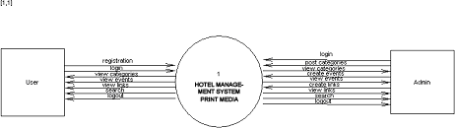

**Top Level DFD:** The Top Level DFD gives the overview of the whole system identifying the major system processes and data flow. This level focuses on the single process that is drawn in the context diagram by ‘Zooming in’ on its contents and illustrates what it does in more detail.

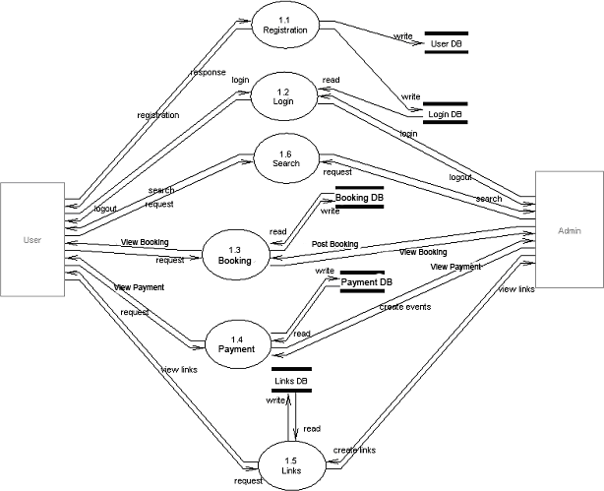

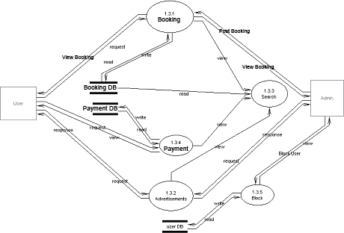**Detailed Level DFD:** In Detailed D.F.Ds the main process is divided into sub processes and we try to find out the flow from one process to another process. We find the interaction among External entities, processes, sub processes and database.

### 3.1.2. Use Case Documentation:

**USE CASE DIAGRAMS:**

A use case describes a sequence of actions that provide something of measurable value to an actor and is drawn as a horizontal ellipse an actor is a person, organization, or external system that plays a role in one or more interactions with your system.

### Use Case Diagram

A use case diagram is a diagram that shows a set of use cases and actors and relationships.

Contents

Use case commonly contain Use cases

Actors

Dependency, generalization and association relationships

### Over all use case

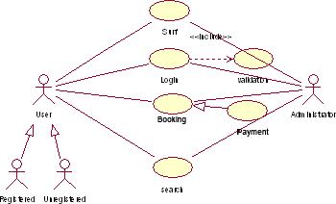

**Un Registration Use Case**

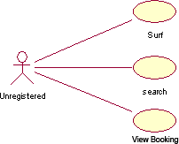

### Registration Use Case

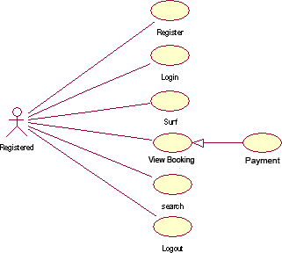

**Administrator Use Case**

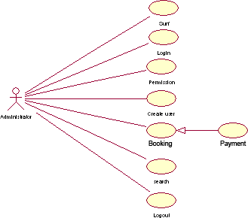

### UML ACTIVITY DIAGRAM:

Activity diagrams are used to document workflows in a system, from the business level down to the operational level. When looking at an Activity diagram, you'll notice elements from state diagram, the Activity diagram is a variation of the state diagram where the "states" represent operations, and the transitions represent the activities that happen when the operation is complete. The general purpose of Activity diagrams is to focus on flows driven by internal processing vs. external events.

### Activity Diagrams:

An activity diagram shows the flow from activity to activity. An activity is an ongoing non-atomic execution within a state machine.

Activities ultimately result in some action, which is made up of executable atomic computations that result in a change in state of the system or the return of a value.

Activity diagrams commonly contain Activity states and action states Transitions

Objects

Like all other diagrams, activity diagrams may contain notes and constrains.

### Login Process



<<Yes>>

Providing credentials

Retry

validation

<<No>>

Services

**Registration Process**

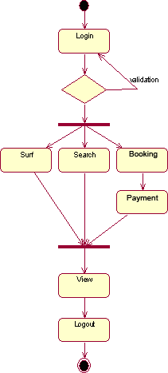

**Administrator Process**

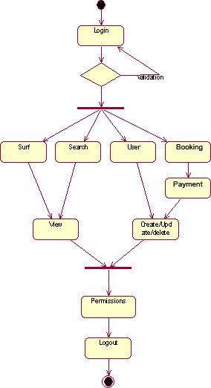

### SEQUENCE DIAGRAMS:

UML sequence diagrams model the flow of logic within your system in a visual manner, enabling you both to document and validate your logic, and are commonly used for both analysis and design purposes. Sequence diagrams are the most popular UML artifacts for dynamic modeling, which focuses on identifying the behavior within your system.

### Sequence and diagrams Sequence Diagram

An interaction diagram shows an interaction, consisting of a set of objects and their relationships, including the messages that may be dispatched among them.

A sequence diagram is an interaction diagram that emphasizes the time ordering of messages.

Graphically, a sequence diagram is a table that shows objects arranged along x-axis and messages, ordered in increasing time, along the y-axis. Contents

Sequence diagrams commonly contain the following: Objects

Links Messages

Like all other diagrams, sequence diagrams may contain notes and constrains.

### Administrator Sequence

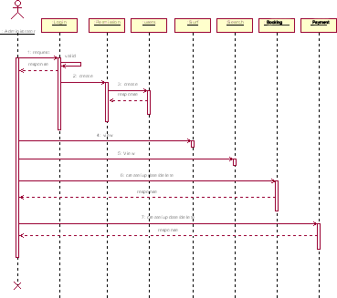

**Registration Sequence**

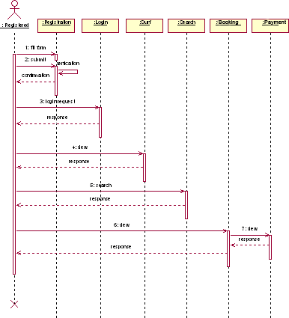

### CLASS DIAGRAMS:

A class diagram describes the static structure of the symbols in your new system. It is a graphic presentation of the static view that shows a collection of declarative (static) model elements, such as classes, types, and their contents and relationships. Classes are arranged in hierarchies sharing common structure and behavior, and are associated with other classes

### Class Diagrams

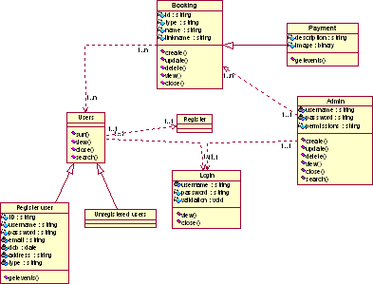

* + 1. **ER DIAGRAM**

**Entity – Relationship Diagram:** This depicts relationship between data objects. The attribute of each data objects noted in the entity- relationship diagram can be described using a data object description. Data flow diagram serves two purposes:

1. To provide an indication of how data are transformed as they move through the system.
2. To depict the functions that transformation the data flow.

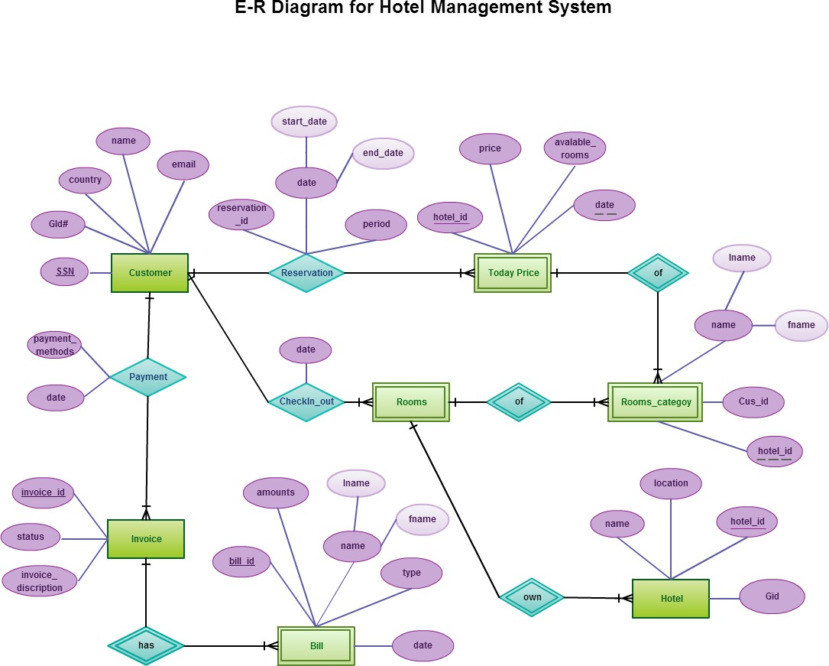

# SYSTEM STUDY AND TECHNOLOGY

### BENEFITS OF ONLINE:

* + - Time saving.
    - Less paper works.
    - Cost efficient.
    - More comfortable environment.
    - Convenience and flexibility.

### SOFTWARE REQURIMENTS:

* + - Html
    - CSS
    - JAVA SCRIPT
    - DATABASE(MySQL)
    - SERVER(APACHE)
    - PROGRAMMING LANGUAGE (PHP).

### TECHNOLOGY USED:

* + 1. **HTML:**

HTML is the standard mark-up language for creating Web pages. HTML stands for Hyper Text Mark-up Language

HTML describes the structure of Web pages using mark-up HTML elements are the building blocks of HTML pages HTML elements are represented by tags

HTML tags label pieces of content such as "heading", "paragraph", "table", and so on

Browsers do not display the HTML tags, but use them to render the content of the page

### CSS:

* CSS stands for Cascading Style Sheets
* CSS describes how HTML elements are to be displayed on screen, paper, or in other media
* CSS saves a lot of work. It can control the layout of multiple web pages all at once
* External stylesheets are stored in CSS files

### DATABASE(MySQL):

MySQL is an open-source relational database management system (RDBMS). Its name is a combination of “My”, the name of the co-founder Michael Widenius’s daughter, and “SQL” the abbreviation for Structured Query Language. MySQL was owned and sponsored by the Swedish company MySQL AB which was bought by Sun Microsystems (now Oracle Corporation). In 2010 when Oracle acquired Sun, Widenius forked the open-source MySQL project to create MariaDB. It was written in C, C++.

### JAVA SCRIPT:

JavaScript (JS) is a lightweight interpreted or just-in-time compiled programming language with first-class functions. While it is most well-known as the scripting language for Web pages, many non-browser environments also use it, such as Node.js, Apache CouchDB and Adobe Acrobat.

JavaScript is a prototype-based, multi-paradigm, dynamic language, supporting object-oriented, imperative, and declarative (e.g. functional programming) styles.

### SERVER(APACHE):

Apache Web Server is an open-source web server creation, deployment and management software. Initially developed by a group of software programmers, it is now maintained by the Apache Software Foundation. Apache Web Server is designed to create web servers that have the ability to host one or more HTTP-based websites. The features include the ability to support multiple programming languages, server-side scripting, an authentication mechanism and database support. Apache Web Server can be enhanced by manipulating the code base or adding multiple extensions/ add-ons.

It is also widely used by web hosting companies for the purpose of providing shared/virtual hosting, as by default, Apache Web Server supports and distinguishes between different hosts that resides on the same machine.

### PROGRAMMING LANGUAGE (PHP):

PHP is an acronym for "PHP: Hypertext Preprocessor". PHP is a widely-used, open source scripting language. PHP scripts are executed on the server.

PHP is free to download and use.

### What is a PHP File?

PHP files can contain text, HTML, CSS, JavaScript, and PHP code.

PHP code are executed on the server, and the result is returned to the browser as plain HTML.

PHP files have extension ".php".

### What Can PHP Do?

PHP can generate dynamic page content

PHP can create, open, read, write, delete, and close files on the server PHP can collect form data

PHP can send and receive cookies

PHP can add, delete, modify data in your database PHP can be used to control user-access

PHP can encrypt data

With PHP you are not limited to output HTML. You can output images, PDF files, and even Flash movies. You can also output any text, such as XHTML and XML.

### Why PHP?

PHP runs on various platforms (Windows, Linux, Unix, Mac OS X, etc.) PHP is compatible with almost all servers used today (Apache, IIS, etc.) PHP supports a wide range of databases

PHP is free. Download it from the official PHP resource: [www.php.net](http://www.php.net/) PHP is easy to learn and runs efficiently on the server side

### FEASIBILITY REPORT:

Preliminary investigation examines project feasibility, the likelihood the system will be useful to the organization. The main objective of the feasibility study is to test the Technical, Operational and Economical feasibility for adding new modules and debugging old running system. All system is feasible if they are unlimited resources and infinite time. There are aspects in the feasibility study portion of the preliminary investigation:

Technical Feasibility Operational Feasibility Economic Feasibility

* + 1. **TECHNICAL FEASIBILITY:**

The technical issue usually raised during the feasibility stage of the investigation includes the following:

Does the necessary technology exist to do what is suggested?

Do the proposed equipment’s have the technical capacity to hold the data required to use the new system?

Will the proposed system provide adequate response to inquiries, regardless of the number orlocation of users?

Can the system be upgraded if developed?

Are there technical guarantees of accuracy, reliability, ease of access and data security?

Earlier no system existed to cater to the needs of ‘Secure Infrastructure Implementation System’.

The current system developed is technically feasible. It is a web-based user interface for audit workflow at NIC-CSD. Thus, it provides an easy access to the users. The database’s purpose is to create, establish and maintain a workflow among various entities in order to facilitate all concerned users in their various capacities or roles. Permission to the users would be granted based on the roles specified. Therefore, it provides the technical guarantee of accuracy, reliability and security. The software and hard requirements for the development of this project are not many and are already available in-house at NIC or are available as free as open source. The work for the project is done with the current equipment and existing software technology. Necessary bandwidth exists for providing a fast feedback to the users irrespective of the number of users using the system.

**4.4.2 IMPLEMENTATION**

Proposed projects are beneficial only if they can be turned out into information system. That will meet the organization’s operating requirements. Operational feasibility aspects of the project are to be taken as an important part of the project implementation. Some of the important issues raised are to test the operational feasibility of a project includes the following: -

Is there sufficient support for the management from the users?

Will the system be used and work properly if it is being developed and implemented?

This system is targeted to be in accordance with the above-mentioned issues. Beforehand, the management issues and user requirements have been taken into consideration. So, there is no question of resistance from the users that can undermine the possible application benefits.

The well-planned design would ensure the optimal utilization of the computer resources and would help in the improvement of performance status.

### ECONOMICAL FEASIBILITY:

Economic feasibility analysis is the most commonly used method for determining the efficiency of a new project. It is also known as cost analysis. It helps in identifying profit against investment expected from a project. Cost and time are the most essential factors involved in this field. During the process of economic feasibility study, we follow certain best practices to get the desired result. We do certain assumptions on the basis of which we give you solid plan of investment.

These include :

Economic feasibility cash flow. Estimated total project cost.

Estimated total earnings. Risk factors.

**5.IMPLEMENTATION**

### 5.1. PHP: Hypertext Preprocessor

PHP is a widely used, general-purpose scripting language that was originally designed for web development to produce dynamic web pages. For this purpose, PHP code is embedded into the HTML source document and interpreted by a web server with a PHP processor module, which generates the web page document.

### PHP Advantages

PHP source code is compiled on-the-fly to an internal format that can be executed by the PHP engine. In order to speed up execution time and not have to compile the PHP source code every time the webpage is accessed, PHP scripts can also be deployed in executable format using a PHP compiler.

PHP is one of the most popular server side scripting languages running today. It is used for creating dynamic webpages that interact with the user offering customized information. PHP offers many advantages; it is fast, stable, secure, easy to use and open source (free).

PHP code is inserted directly into the HTML that makes up a website. When a visitor comes to the website, the code is executed. Because PHP is a server side technology, the user does not need any special browser or plug-ins to see the PHP in action.

The beauty of PHP lies in its simplicity. It is easy to understand and learn, especially for those with backgrounds in programming such as C, JavaScript and HTML. The language is similar to C and Perl so that anyone with a background in either C or Perl programming will feel comfortable using and understanding PHP. PHP also runs on just about every platform including most UNIX, Macs and Windows versions.

Another key advantage of PHP is its connective abilities. PHP uses a modular system of extensions to interface with a variety of libraries such as graphics, XML, encryption, etc. In addition, programmers can extend PHP by writing their own extensions and compiling them into the executable or they can create their own executable and load it using PHP's dynamic loading mechanism.

A huge advantage that PHP offers is its community. Since PHP is an A huge advantage that PHP offers is its community. Since PHP is an open source project, the PHP community is willing to share. If you're looking for a particular script, chances are another user has already created something similar. Check within the PHP community for availability. Likewise, if you have created a function that others might enjoy, be sure to post the code for others.

A PHP scripting block always starts with <?php and ends with ?>. A PHP scripting block can be placed anywhere in the document.

On servers with shorthand support enabled you can start a scripting block with <? and end with ?>.

For maximum compatibility, we recommend that you use the standard form (<?php) rather than the shorthand form.

<?php

?>

A PHP file normally contains HTML tags, just like an HTML file, and some PHP scripting code.

Below, we have an example of a simple PHP script which sends the text "Hello World" to the browser:

<html>

<body>

<?php

echo "Hello World";

?>

</body>

</html>

Each code line in PHP must end with a semicolon. The semicolon is a separator and is used to distinguish one set of instructions from another. There are two basic statements to output text with PHP: echo and print. In the example above we have used the echo statement to output the text "Hello World".

Note: The file must have a .php extension. If the file has a .html extension, the PHP code will not be executed.

### Comments in PHP

In PHP, we use // to make a single-line comment or /* and */ to make a large comment block.

<html>

<body>

<?php

//This is a comment

/*

This is

a comment block

*/

?>

</body>

</html>

### Variables in PHP

Variables are used for storing a values, like text strings, numbers or arrays. When a variable is declared, it can be used over and over again in your script.

All variables in PHP start with a $ sign symbol. The correct way of declaring a variable in PHP:

$var_name = value;

PHP is a Loosely Typed Language

In PHP, a variable does not need to be declared before adding a value to it. In the example above, you see that you do not have to tell PHP which data type the variable is.

PHP automatically converts the variable to the correct data type, depending on its value.

In a strongly typed programming language, you have to declare (define) the type and name of the variable before using it.

In PHP, the variable is declared automatically when you use it.

### Sessions

A PHP session variable is used to store information about, or change settings for a user session. Session variables hold information about one single user, and are available to all pages in one application.

### PHP Session Variables

When you are working with an application, you open it, do some changes and then you close it. This is much like a Session. The computer knows who you are. It knows when you start the application and when you end. But on the internet there is one problem: the web server does not know who you are and what you do because the HTTP address doesn't maintain state.

A PHP session solves this problem by allowing you to store user information on the server for later use (i.e. username, shopping items, etc). However, session information is temporary and will be deleted after the user has left the website. If you need a permanent storage you may want to store the data in a database.

Sessions work by creating a unique id (UID) for each visitor and store variables based on this UID. The UID is either stored in a cookie or is propagated in the URL.

### Starting a PHP Session

Before you can store user information in your PHP session, you must first start up the session.

Note: The session start() function must appear BEFORE the <html> tag:

<?php session start(); ?>

<html>

<body>

</body>

</html>

The code above will register the user's session with the server, allow you to start saving user information, and assign a UID for that user's session.

Storing a Session Variable

The correct way to store and retrieve session variables is to use the PHP

$_SESSION variable:

<?php

session start();

// store session data

$_SESSION['views']=1;

?>

<html>

<body>

<?php

//retrieve session data

echo "Pageviews=". $_SESSION['views'];

?>

</body>

</html> Output:

Pageviews=1

In the example below, we create a simple page-views counter. The isset() function checks if the "views" variable has already been set. If "views" has been set, we can increment our counter. If "views" doesn't exist, we create a "views" variable, and set it to 1:

<?php session_start();

if(isset($_SESSION['views']))

$_SESSION['views']=$_SESSION['views']+1; else

$_SESSION['views']=1;

echo "Views=". $_SESSION['views'];

?>

### Destroying a Session

If you wish to delete some session data, you can use the unset() or the session_destroy() function.

The unset() function is used to free the specified session variable:

<?php unset($_SESSION['views']);

?>

You can also completely destroy the session by calling the session_destroy() function:

<?php session_destroy(); ?>

Note: session_destroy() will reset your session and you will lose all your stored session data.

### PHP Form Handling

The most important thing to notice when dealing with HTML forms and PHP is that any form element in an HTML page will automatically be available to your PHP scripts.

Example

The example below contains an HTML form with two input fields and a submit button:

<html>

<body>

<form action="welcome.php" method="post"> Name: <input type="text" name="fname" /> Age: <input type="text" name="age" />

<input type="submit" />

</form>

</body>

</html>

The PHP $_GET and $_POST variables are used to retrieve information from forms, like user input.

When a user fills out the form above and click on the submit button, the form data is sent to a PHP file, called "welcome.php":

"welcome.php" looks like this:

<html>

<body>

Welcome <?php echo $_POST["fname"]; ?>!<br /> You are <?php echo $_POST["age"]; ?> years old.

</body>

</html>

Output could be something like this: Welcome Sam!

You are 20 years old.

The PHP $_GET and $_POST functions will be explained in the next chapters.

Form Validation

User input should be validated on the browser whenever possible (by client scripts). Browser validation is faster and reduces the server load.

You should consider server validation if the user input will be inserted into a database. A good way to validate a form on the server is to post the form to itself, instead of jumping to a different page. The user will then get the error messages on the same page as the form. This makes it easier to discover the error.

## 6. OUTPUT SCREENS

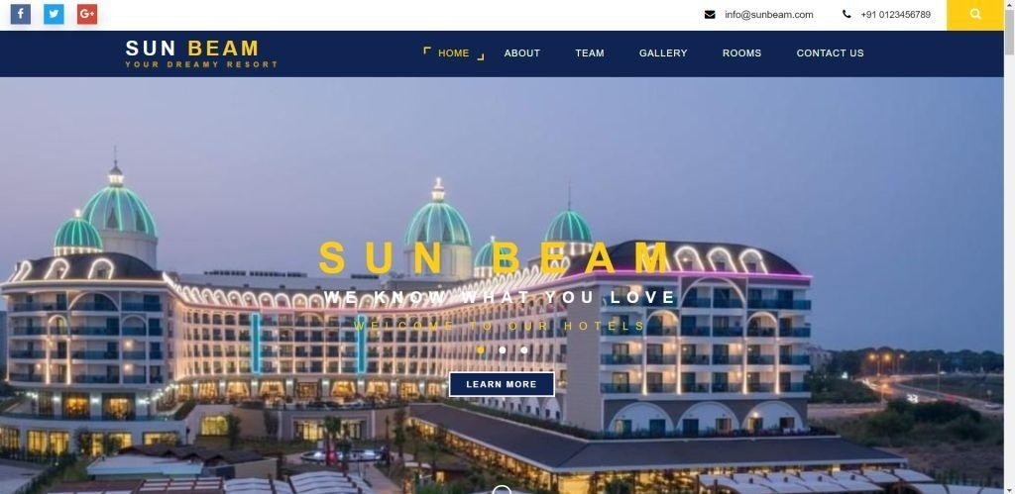

*Fig.1 Home page*

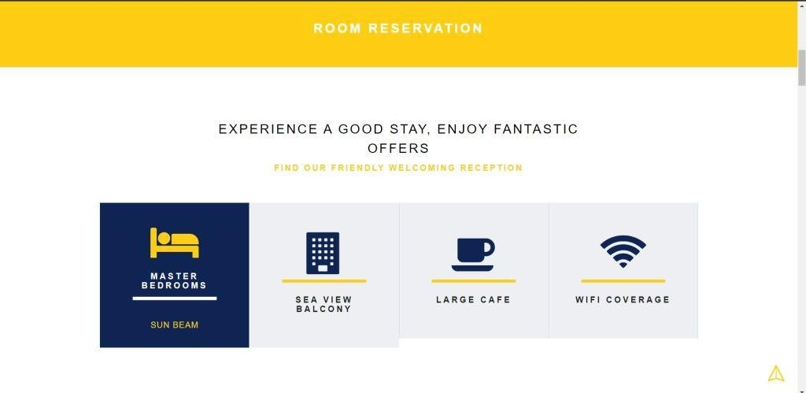

*Fig.2 Room page*

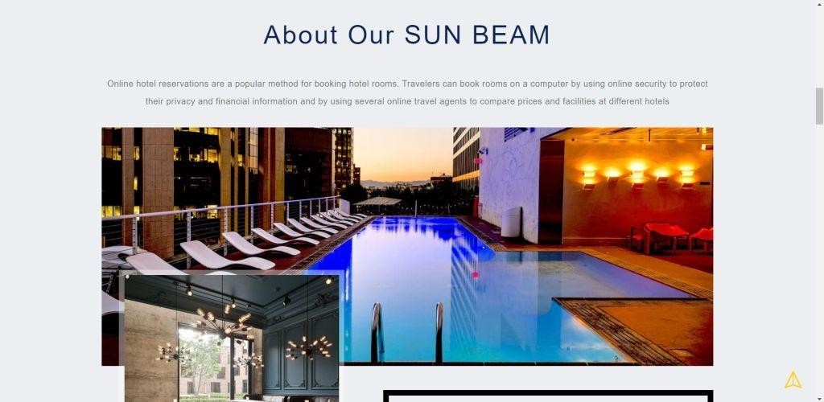

*Fig.3 About page*



*Fig.4 Gallery page*

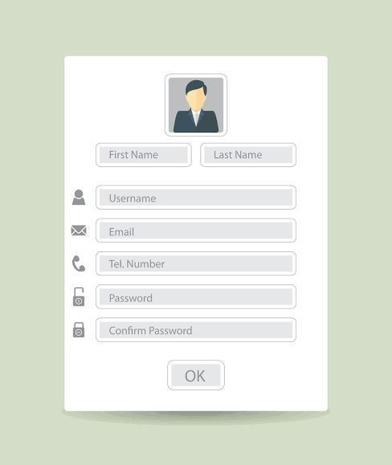

*Fig.5 Registration form*

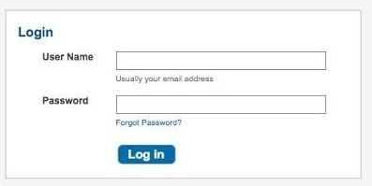

*Fig.6 Login page*

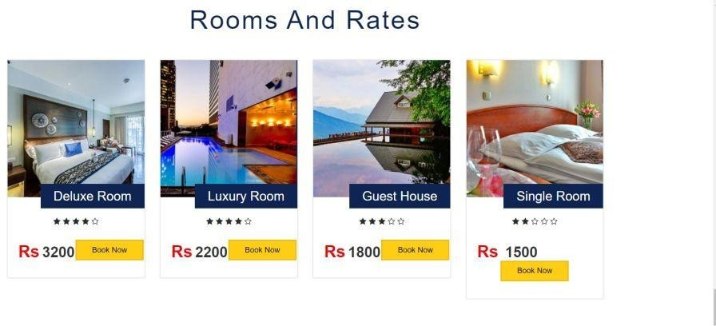

*Fig.7 Room rates*

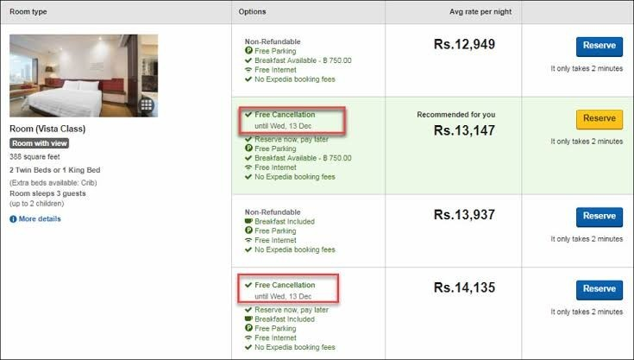

*Fig.8 Room policy*

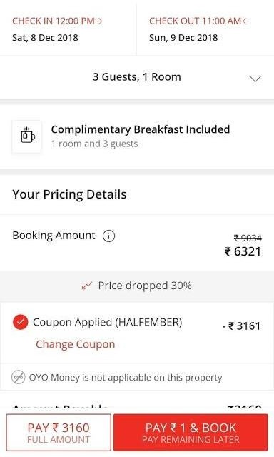

*Fig.9 Room Confirmation page*

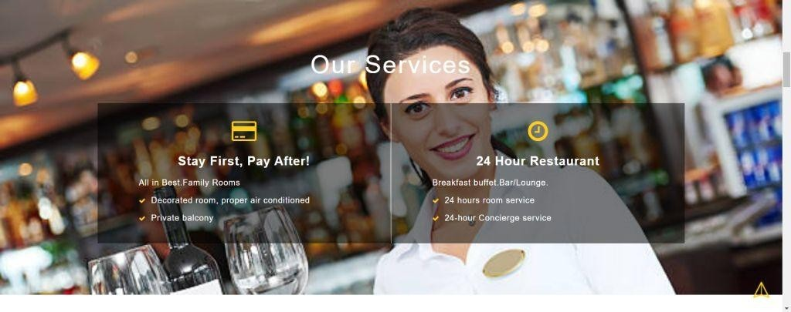

*Fig.10 Services page*

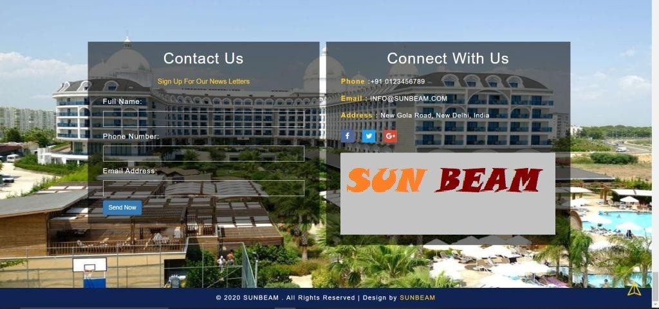

*Fig.11 Contact page*

## 7.PROBLEM STATEMENT

The old manual system was suffering from a series of drawback. Since whole of the system was to be maintained with hands the process of keeping, maintaining and retrieving the information was very tedious and lengthy. The records were never used to be a systematic order there used to be lots of difficulties in associating any particular transaction with a particular context. If any information was to be found it was required to go through the different registers, documents there would never exit anything like report generation. There would always be unnecessary consumption of time while entering records and retrieving records. Once the records were entered it was very difficult to update these records.

**FOLLOWING POINTS SHOULD BE CONSIDERED :**

* + - Details of the information needed for each document and report.
    - The required frequency and distribution for each document.
    - Probable sources of information for each document and report.

## ADVANTAGES AND DISADVANTAGES

### Advantages:

Sometimes it happens that the rooms get booked soon when one visits the place therefore user can make advance booking using this system.

It saves user time in search of rooms.

The system is useful as it calculates an exact cost for requested number of days.

It saves organization resources and expenses.

This system is effective and saves time and cost of users. Easy registration.

### Disadvantages:

The booking process usually requires a customer identity which the system cannot detect.

It requires a reliable internet connection.

### Applications:

This system can be applied in hotels. It can also be implemented in resorts.

## 8.CONCLUSION

**HOTEL MANAGENMENT SYSTEM** is a Web-portal Development Company specializing in providing custom solutions for small businesses. We strive to build solutions to your specific needs to get the job done right the first time. We pay special attention to the ease of use and utilize the latest in technology.

This system is developed for the exclusively for the people . It provides facilities to the user with user friendly modules with sub modules. This system is developed in understandable approach which can be easier to the layman of the computers. This system is developed totally GUI based and with smart links.

This project is designed to meet the requirements of Online Hotel Management. It has been developed in JSP, Servlets keeping in mind the specifications of the system. For designing the system we have used simple data flow diagrams.

Overall the project teaches us the essential skills like: Using system analysis and design techniques like data flow diagram in designing the system. Understanding the database handling and query processing.

## 9.REFERENCES

* https://[www.w3schools.com/html](http://www.w3schools.com/html)
* https://[www.w3.org/style/css](http://www.w3.org/style/css)
* https://wikepedia.or/wiki/MySQL
* https://wikipedia.org/wiki/javascript
* https://httpd.apache.org
* https://w3schools.com/php
* Learning PHP, MySQL & JavaScript: With jQuery, CSS & HTML
* Java: The Complete Reference: Herbert Schildt